Live Plug Connector
Technical Specifications V2.5

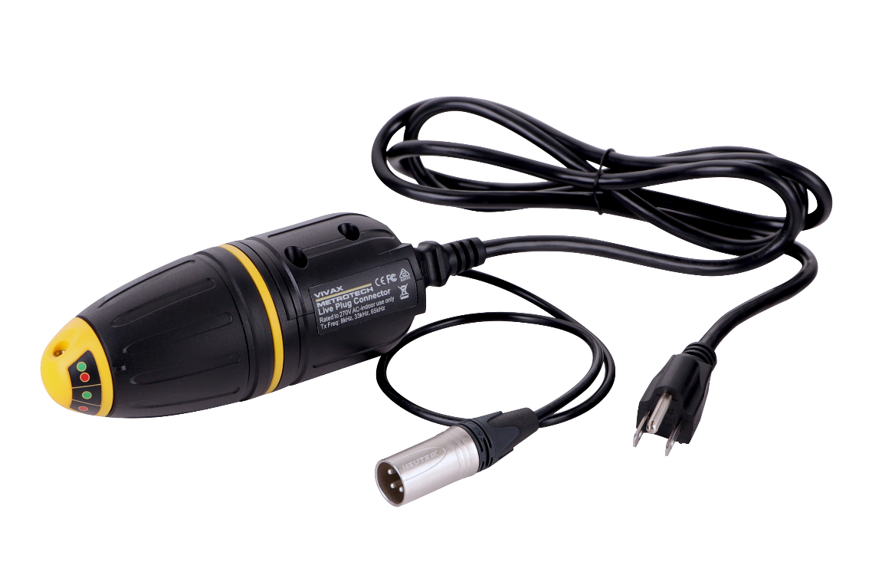
Worldwide Locations

World Headquarters, United States of America | Central/South America and the Caribbean
Vivax-Metrotech Corporation  3251 Olcott Street, Santa Clara, CA 95054, USA  T/Free : 1-800-638-7682  Tel : +1-408-962-9990  Fax : +1-408-734-1799  Website : www.vivax-metrotech.com  Email : SalesUSA@vxmt.com | Ventas para América Latina  3251 Olcott Street, Santa Clara, CA 95054, USA  T/Free : 1-800-446-3392  Tel : +1-408-734-1400  Fax : +1-408-743-5597  Website : www.vivax-metrotech.com  Email : LatinSales@vxmt.com
Canada | United Kingdom
Vivax Canada, Inc.  41 Courtland Ave Unit 8, Vaughan, ON L4K 3T3, Canada  Tel : +1-289-846-3010  Fax : +1-905-752-0214  Website : www.vivax-metrotech.com  Email : SalesCA@vxmt.com | Vivax-Metrotech Ltd.  Unit 1, B/C Polden Business Centre, Bristol Road, Bridgwater, Somerset, TA6 4AW, UK  Tel : +44(0)1793 822679  Website : www.vivax-metrotech.com  Email : SalesUK@vxmt.com
France | Germany
Vivax-Metrotech SAS  Technoparc ‐ 1 allée du Moulin Berger, 69130 Ecully, France  Tel : +33(0)4 72 53 03 03  Fax : +33(0)4 72 53 03 13  Website : www.vivax-metrotech.fr  Email : SalesFR@vxmt.com | Metrotech Vertriebs GmbH  Am steinernen Kreuz 10a  D-96110 Schesslitz  Tel : +49 954 277 227 43  Website : www.vivax-metrotech.de  Email : SalesEU@vxmt.com

- Typical Applications
Item | Parameter
Description | Live Plug Connector (LPC Separation Filter)
Uses | To apply the transmitter signal to target lines carrying up to 240V AC

- Characteristics
Item | Parameter
Construction | High impact ABS injection molded housing
Weight | 0.8lbs (0.36kg)
Dimension | 2.5-inch (Dia.) x 6.2-inch (L) (64mm x 156.4mm)
Temperature Range | Operating: -4ºF to 122ºF (-20ºC to 50ºC)  Storage: -40ºF to 140ºF (-40ºC to 60ºC)
What's in the Box | - Live Plug Connector  - 3-Pin Power cord (per region)  - Quick Guide
External Connectors | 1 x XLR 3-Pin plug connects to the transmitter  1 x 3-Pin AC Plug for up to 240V AC
Compatible Transmitters | Loc3 series, Loc series, VM series, vScan

- Operational
Item | Parameter
Controls | Rotary knob – phase switching
Operating Frequencies | 8 kHz, 33 kHz, 65 kHz

- Shipping and Packaging
Item | Parameter
Shipping Weight | 1.4lbs (0.64kg)
Shipping Dimensions | 8.7-inch(L) x 5-inch(W) x 2.7-inch(H) (222mm x 127mm x 68mm)

- Warranty
Item | Parameter
Warranty | 12 months

All products are designed and manufactured per ISO 9001:2015.

Disclaimer: Product and accessory specification and availability information are subject to change without prior notice.

